The motivation for this problem comes from this problem asked by Nvidia.

You are given a list of N points (x1, y1), (x2, y2), ..., (xN, yN) representing a convex polygon. You can assume these points are given in order; that is, you can construct the polygon by connecting point 1 to point 2, point 2 to point 3, and so on, finally looping around to connect point N to point 1.

Determine if a new point p lies inside this polygon.

Note: If p is on the boundary of the polygon, return false.

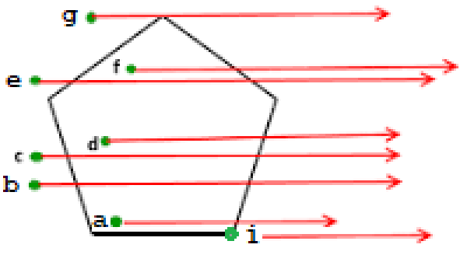For example, in the figure to the right, the points a, d, and f all lie inside the polygon, the remaining points (including point i which lies on an edge) are all considered to lie outside the polygon.

My first step in solving this problem was to Google it, and according to:

<https://www.geeksforgeeks.org/how-to-check-if-a-given-point-lies-inside-a-polygon/>

1. *Draw a horizontal line to the right of the point and extend it to infinity.*
2. *Count the number of times the line intersects with polygon edges.*
3. *If either the count of intersections is even (remember, zero is even), or if the point lies on an edge of polygon, the point lies outside.*
4. *A point is inside the polygon if the count of intersections is odd and does NOT lie on an edge.*

To help with this problem, you have been given the completed Point class. The constructor for this class has two parameters, the first parameter is the x-coordinate and the second is the y-coordinate. It has accessor methods getX() that returns the x-value and getY() that returns the y-value.

The first method to implement is the static method getSlopeIntercept(Point p1, Point p2), which given two points p1 and p2, returns a double[] containing two values. The value in index 0 is the slope of the line containing the points p1 and p2. The value in index 1 is the y-intercept of the line containing the points p1 and p2. You may assume the line determined by p1 and p2 is not a vertical line.

The following code shows the results of the getSlopeIntercept method.

|  |  |
| --- | --- |
| The following code | Returns |
| double[] eq = InsideOrOutside.getSlopeIntercept(  new Point(1., 2.), new Point(3., 7.)); |  |
| eq[0] | 2.5 |
| eq[1] | -0.5 |

The second method to implement is the static method intersectsLineSegmentToRight(Point p, Point t1, Point t2), which returns a boolean. The method returns true if:

* The ray drawn horizontally to the right from the parameter p intersects the (interior of the) line segment connecting points t1 and t2. That is, if the ray interests at the endpoints, the method returns false.
* And the Point p is not on the line segment connecting points t1 and t2.

The following code shows the results of the intersectsLineSegmentToRight method.

|  |  |
| --- | --- |
| The following code | Returns |
| boolean doesInter = InsideOrOutside.intersectsLineSegmentToRight  (new Point(1., 1.), new Point(0., 0.), new Point(6., 3.)); |  |
| doesInter | true |
| boolean doesInter = InsideOrOutside.intersectsLineSegmentToRight  (new Point(3., 2.), new Point(1., 4.), new Point(2., 7.)); |  |
| doesInter | false |
| doesInter = InsideOrOutside.intersectsLineSegmentToRight  (new Point(-2., 4.), new Point(1., 4.), new Point(2., 7.)); |  |
| doesInter | false |
| doesInter = InsideOrOutside.intersectsLineSegmentToRight(new Point(2., 5.), new Point(1., 4.), new Point(4., 7.)); |  |
| doesInter | false |

The third method is the (non static) method numberEdgesIntersection(Point p), which returns the number of Polygon edges the Horizontal ray from Point p to the right intersects.

The following code shows the results of the numberEdgesIntersection method.

|  |  |
| --- | --- |
| The following code | Returns |
| Point[] poly1 = { new Point(1,1), new Point(2, 4),  new Point(6, 6), new Point(7,5), new Point(3, 2)}; |  |
| InsideOrOutside ioo = new InsideOrOutside(poly1); |  |
| ioo.numberEdgesIntersection(new Point(0, 2.5)) | 2 |
| ioo.numberEdgesIntersection(new Point(3.0, 3.0)) | 1 |
| ioo.numberEdgesIntersection(new Point(8.0, 5.0)) | 0 |

The fourth (and final) method is the (non static) method insidePolygon(Point p), which returns true if Point p is inside the polygon, otherwise, return false. Remember, if Point p lies on the boundary, return false.

The following code shows the results of the insidePolygon method.

|  |  |
| --- | --- |
| The following code | Returns |
| Point[] poly1 = { new Point(1,1), new Point(2, 4),  new Point(6, 6), new Point(7,5), new Point(3, 2)}; |  |
| InsideOrOutside ioo = new InsideOrOutside(poly1); |  |
| ioo.insidePolygon(new Point(0, 2.5)); | false |
| ioo.insidePolygon(new Point(3.0, 3.0)); | true |
| ioo.insidePolygon(new Point(8.0, 5.0)); | false |

This page intentionally left blank